Images Tutorial
Updated , by Linode
linode platform cloud manager
Try this guide to receive $100 at signup on a new account.
Note
The Images service has been updated to include expanded size limits and the ability to Upload an Image (this feature is currently in beta). Images will remain free of charge during the beta and transition to a paid service at a future date. Additional details and pricing information are available on the Images product page.
Linode’s Images service allows users to store custom disk images in the Cloud preconfigured with the exact software and settings required for certain applications and workloads. These Images can be quickly deployed to new or existing Linode, saving users time from manually setting up their entire system after each deployment.

Pricing and Availability
Images are currently available at no charge to Linode customers and can be deployed across all regions.
Note
Pricing change: Images will transition to a paid service with a cost of $0.10/GB per month for each Custom Image stored on an account. This change will be communicated to customers in advance. Recovery Images, generated automatically after a Linode is deleted, are provided at no cost for a finite period of time.

Types of Images
All Images stored on your Account are visible from the main Images page within the Cloud Manager. Images are divided between two tables: Manual Images and Automatic Images.
- Manual Images: Custom Images that are manually created by a user on the account. These Images were either captured from an existing Linode’s disk or uploaded through an image file. Custom Images do not expire and will remain on the account until they are manually deleted.
- Automatic Images: Temporary Recovery Images that are automatically created when a Linode is deleted. Recovery Images have a defined expiration data and, once expired, will automatically be deleted. The expiration date is based on how long the Linode was active, as well as a few other factors.

Creating a New Image
Two different methods can be used to manually create a Custom Image, each of which is discussed within this guide:
- Capturing an Image
- Uploading an Image

Capturing an Image

Requirements and Considerations
- Disk must be formatted using ext3/ext4 filesystems. Images cannot be created if you are using raw disks or disks that have been formatted using custom filesystems. CoreOS disk images are in RAW format. Images made from CoreOS disks can’t be used to deploy new Linodes.
- Power off Linode to avoid database corruption. If your Linode is running any active databases, it’s recommended to power off the Linode down prior to creating the image. Creating an image that includes a running database can cause corruption or data loss in the imaged copy of the database.
- Only the selected disk is saved to the Image. The Image is comprised only of the disk selected during the creation process. The Image does not store other aspects of the Linode, such as Configuration Profiles, Block Storage Volumes, IP Addresses, and other Linode-based settings.
Additional overall limits of the Images service are outlined within the Limits section below.

Capturing an Image through the Cloud Manager
- Log in to the Cloud Manager and open the Capture Image form by navigating to the Images page, clicking the Create Image button, and staying on the Catpure Image tab.
- Select your Linode and Disk from their respective dropdown lists and type in an optional Label and Description for the Image. If no Label is entered, the label for the disk will be used. When selecting a Linode and Disk, keep in mind any limitations that may prevent the Image from creating successfully.
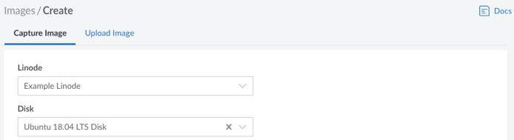
- Click the Create button to start creating the Image. It will take some time to fully complete. You can check the status of this process by navigating to the main Images page, finding the new image in the Manual Images table, and looking at the Status column. If the Image has been captured and processed, the status should be set to Ready. The Size of the Image is based on the disk’s usage, not the size of the disk itself.
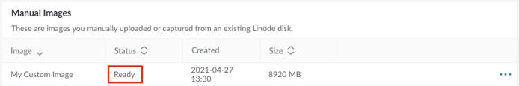

Uploading an Image

Requirements
- Raw disk image: The image file must be a raw disk image (.img). Other file formats will not work.
- Compressed using gzip: The image file must be compressed using gzip (.gz) before uploading it. Other compression algorithms are not compatible.
- Maximum file size is 5GB: The maximum size for an image file is 5GB (compressed).
- Pricing considerations: Once pricing goes into effect, you will be charged for the uncompressed size of the Image.
- For compatibility, use unpartitioned disks formatted with ext3 or ext4 file systems: Network Helper and other Linode Helpers are compatible with non-partitioned image files formatted using the ext3 or ext4 file systems. Partitioned disks and other file systems may be used, but some manual configuration may be required.

Uploading an Image through the Cloud Manager
- Log in to the Cloud Manager and open the Upload Image form by navigating to the Images page, clicking the Create Image button, and selecting the Upload Image tab.
- Type in the Label of the new Image along with an optional Description. Select the Region you would like the Image to be created within. Since Images can be deployed to any data center (regardless of where they are located), it’s recommended that you select the one closest to you geographically for the fastest upload speed.
- Click the Generate URL button to create the Image and generate a custom URL. The URL, which is displayed both separately and within an example curl command, is used to upload your image file. Click Copy curl Request to copy the curl command. Alternatively, copy the URL by clicking Copy URL, which allows you to write a custom curl command or use a different upload tool altogether.
- Open your preferred terminal application on the system where your image is currently located, likely your local computer.
- Upload the image file by pasting the curl command into the terminal window, updating the --upload-file option to reference the file name and path of your image. Alternatively, copy the curl command below, replacing example.img with the file name and path of your image and replacing url with the URL that was generated from the previous step.
curl -H "Content-Type: application/octet-stream" --upload-file example.img.gz "url" --progress-bar --output /dev/null
This command may take a while to complete, depending on the size of the image file and the transfer speed. During this time, a progress bar will be displayed. By default, curl is already preinstalled on most Linux, Mac, and updated Windows 10 systems using the latest PowerShell terminal. If curl is not installed, install it now by following the recommended instructions for your operating system or package manager.
- Confirm the image file has been uploaded and is available by navigating to the main Images page, finding the new Image in the Manual Images table, and looking at the Status column. If the Image has been uploaded and processed, the status should be set to Ready. If the status is still Pending Upload but the curl command completed successfully, wait a few more minutes for the Image to be processed.
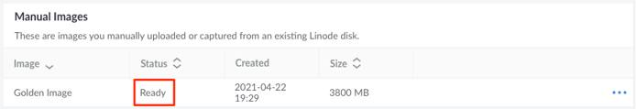
If there is an error when processing the uploaded image file, the newly created Image may be deleted and an error message will be written to the Events log. See What Are the Cloud Manager Events and Activity Feeds for more details on viewing Cloud Manager Events.

Managing Images
To take action on an Image, locate the Image within the Images page of the Cloud Manager and click the corresponding ellipsis options menu. From here, there are a few actions that can be initiated:
- Edit: Change the Label and Description for the Image.
- Deploy to a New Linode: Create a new Linode using the Image.
- Deploy to an Existing Linode: Rebuild the Linode using the Image.
- Delete: Delete the Image (cannot be undone).

Deploying an Image to a New Linode
- Log in to the Cloud Manager and navigate to the Images page.
- On this page, locate the Image you wish to deploy and click the corresponding ellipsis options menu. Select Deploy to a New Linode.
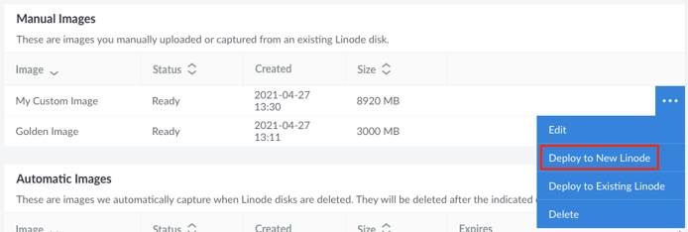
- You are redirected to the Create Linode form with the chosen Image preselected. Complete the remainder of this form, making sure to select your desired Region, Linode Plan, Label, Root Password, and any other options that may be needed. See Getting Started with Linode → Create Linode for full instructions on creating a Linode.
- Click the Create Linode button to create the Linode based on the selected Image.

Rebuilding and Deploying an Image to an Existing Linode
- Log in to the Cloud Manager and navigate to the Images page.
- On this page, locate the Image you wish to deploy and click the corresponding ellipsis options menu. Select Deploy to an Existing Linode.
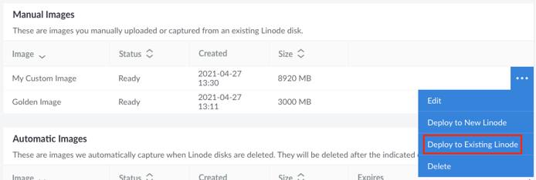
- You are redirected to the dashboard page for that Linode and the Rebuild form is displayed with the chosen Image preselected. Complete the remainder of this form, making sure to select your desired Root Password, and any other options that may be needed. See Rescue and Rebuild → Rebuilding for full instructions on rebuilding a Linode.
- Click the Rebuild Linode button to rebuild the Linode. All existing disks will be deleted and a new disk will be created using the selected Image.

Limits
- Image size limit: The maximum size for each Custom Image is 6 GB.
- Account storage limit: The maximum combined size for all Custom Images on an account is 150 GB.
- Account quantity limit: There can be up to 25 Custom Images per account.

